EyeNet (November, 2022)

Top Real-World Coding Competencies for Young Ophthalmologists—Part 1
By Janice Law, MD, and Joy Woodke, COE, OCS, OCSR.

Web Extra: Examples of Cheat Sheets

Create references that are small enough to hang with your work badge or fit in your coat pocket. The examples below are based on the charts that Janice Law, MD, created for her office use in November 2022.

Note: These examples can provide templates for your personal cheat sheets. Make sure your cheat sheets are up to date and accurate for your payer(s).

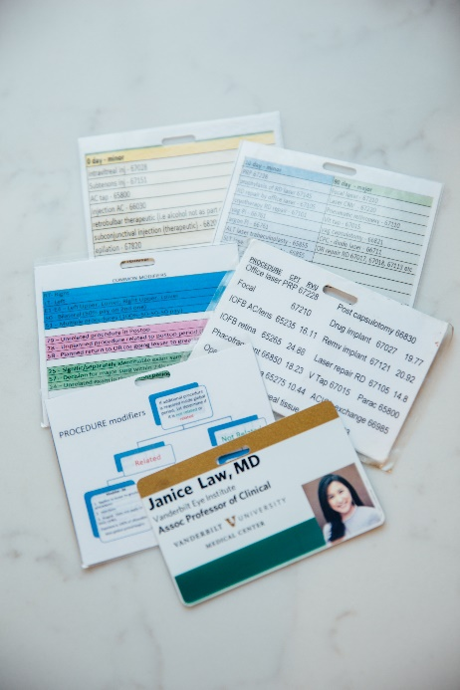

Example of a Cheat Sheet for Exam Modifiers
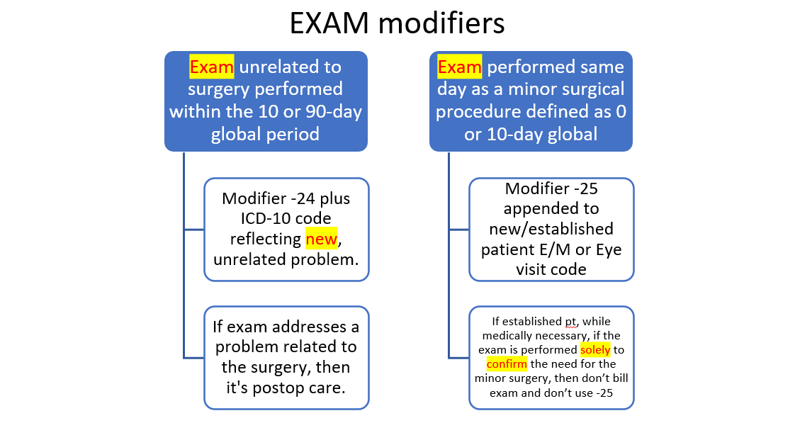

Example of a Cheat Sheet for Procedure Modifiers:
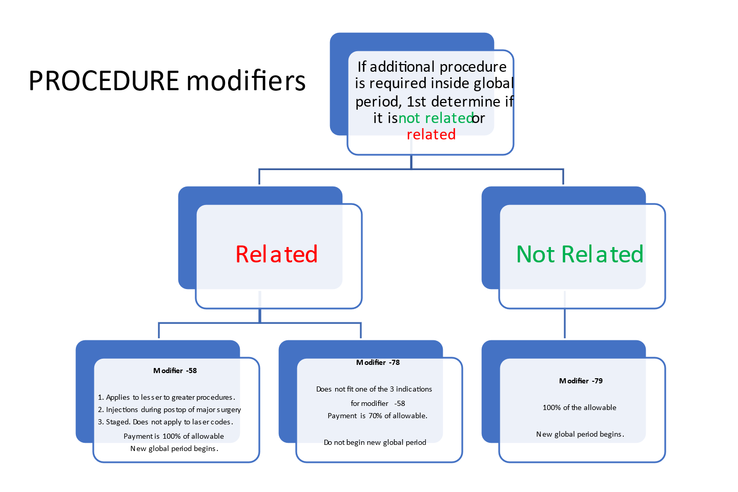
Example of a Cheat Sheet for Modifier Codes:
Common Modifiers
RT – Right
LT – Left
E1-E4 – Left Upper, Lower; Right Upper, Lower
50 – Bilateral (50% pay on 2nd one)
51 – Multiple procedures (100%-50-50-50 pay)
79 – Unrelated procedure in Postop
78 – Unplanned procedure related to postop period (70% pay)
58 – Planned return to OR (or going lesser to greater) (100% pay)
25 – Signific/separately identifiable exam same day as minor proc
57 – Decision for major surg within 24h resulted from my exam
24 – Unrelated exam in the postop period
26 – Professional Component of a combo code with TC
22 – procedure provided beyond normal (complex, increased time)
53 – Discontinued services if anesthesia initiated (30% payment)

Example of a Cheat Sheet for Exam RVUs:
New Patient | E/M level | wRVU | Time (min) | Established Patient | E/M level | wRVU | Time (min)
 | 99243 | 1.88 | Consult |  | 99212 | 0.7 | 10-19
 | 99202 | 0.93 | 15-29 |  | 99213 | 1.3 | 20-29
 | 99203 | 1.6 | 30-44 |  | 99214 | 1.92 | 30-39
 | 99204 | 2.6 | 45-59 |  | 99215 | 2.8 | 40-54
 | 99205 | 3.5 | 60-74 |  | *99417 | 0.61 | *>55 min +15 min
 | *99417 | 0.61 | *>75min +15 min |  | 92012 | 0.92 | EYE code (no time)
 | 92002 | 0.88 | EYE code (no time) |  | 92014 | 1.42
 | 92004 | 1.82 |  | * Prolonged service, code w/level 5

Example of a Cheat Sheet for Procedure RVUs:
CPT | wRVU | $$
99250 | 0.4 |  | Fundus Photos
92134 | 0.45 |  | Optical Coherence Tomography
76512 | 0.56 |  | B scan
67028 | 1.44 |  | Injection
99214 | 1.92 |  | Exam
67228 | 4.39 |  | Pan retinal photocoagulation
67041 | 14.5 |  | Pars Plana Vitrectomy (PPV), with membrane peel
67042 | 16.33 |  | ILM peel
67108 | 17.13 |  | RD repair with PPV
67113 | 19 |  | Complex RD repair
66711 | 5.62 |  | CPC diode
67800 | 1.41 |  | Chalazion Removal
92201 | 0.4 |  | Extended ophthalmoscopy, peripheral retinal disease
92202 | 0.26 |  | Extended ophthalmoscopy, optic nerve or macula
92020 | 0.37 |  | Gonioscopy

Example of a Cheat Sheet for Ophthalmic Procedures Minor/Major:
0 day - minor | 10 day - minor | 90 day - major
intravitreal inj - 67028 | PRP 67228 | Focal laser - 67210
Subtenons inj - 67515 | prophylaxis of RD laser 67145 | Laser CNV - 67220
AC tap - 65800 | RD repair by office laser - 67105 | Pneumatic retinopexy - 67110
retrobulbar therapeutic (i.e., alcohol not as part of anesthesia) - 67500 | cryotherapy RD repair - 67101 | Vit tap - 67015 according to Palmetto! 90 days
subconjunctival injection (therapeutic) - 68200 | yag PI - 66761 | yag capsulotomy - 66821
epilation - 67820 | argon PI - 66761 | CPC - diode laser - 66711
corneal FB removal - 65222 | ALT laser trabeculoplasty - 65855 | OR repair RD 67107, 67108, 67113 etc.
 | SLT laser trabeculoplasty - 65855
 | Chalazion removal x 1 - 67800
 | Chalazion removal multi - 67085
 | Eyelid lesion removal - 67840
 | injection AC - 66030

